Amusement Park Ride Circular Motion Analysis (20 pts)

1. Pick an amusement park ride that utilizes circular motion. ( Like the Rotor we saw in the lesson.)
2. Copy and paste an image of the ride and a link to the park where the ride exists. (Located at <https://www.lunaparksydney.com/> Luna Park in Sydney Australia

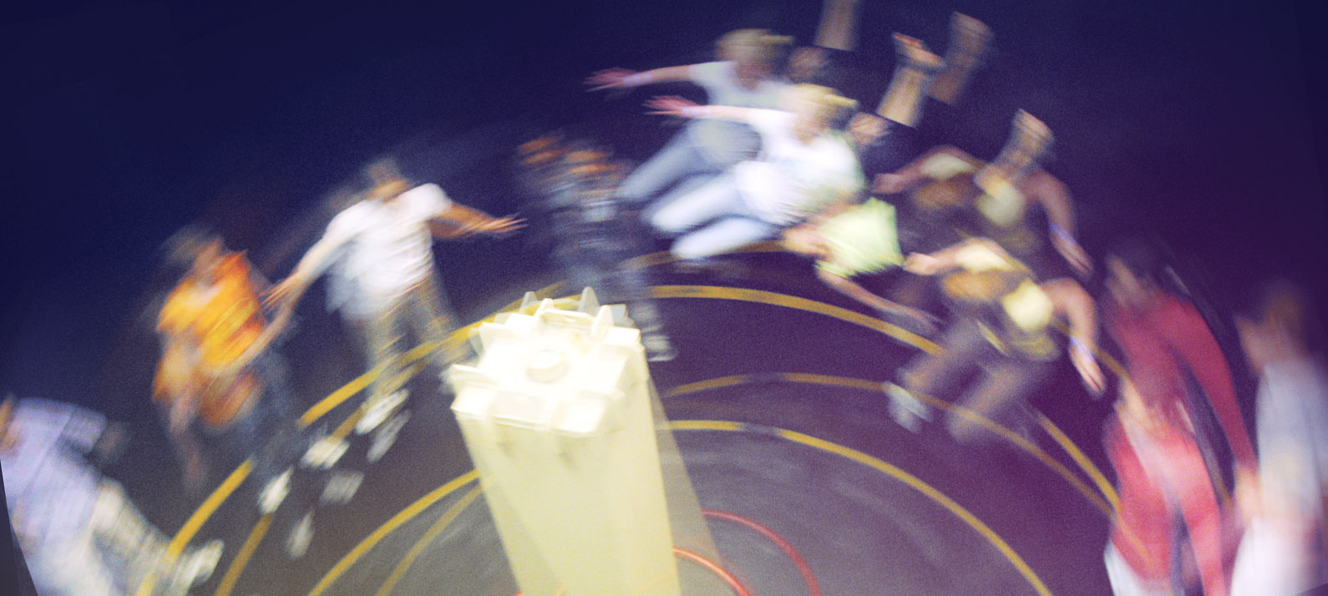

1. Use online resources and/or your photo to demonstrate how the ride creates a centripetal force by identifying the forces used to produce the centripetal force (think about relative magnitude and direction). For our Rotor Example, the normal reaction force of the wall on the rider is the identify of the centripetal force)
2. Draw a freebody for your body of interest. (For our sample, the freebody diagram is just like your answer to P257 #10a.)
3. Estimate the magnitudes of the maximum velocity and maximum acceleration for a typical rider. You can estimate a typical rider with a mass of 60 kg. For reference, humans can normally withstand accelerations up to 4g, but anything more would be nauseating and or cause a person to pass out. (#10b asks you for the velocity. I’d like you to find the velocity and centripetal acceleration experienced by a typical rider.)
4. If you were asked to research this kind of ride for possible inclusion in a new park, discuss the type of rider will enjoy this ride given the magnitude of acceleration you calculate.